Project Title: RoPro (O2TUK)
Duration : Jan 2019 to till date(13 months)
Technology Stack : Java, Spring MVC, JPA(Hibernate), Tomcat8, Restful web services, MySQL, JSP, Java Script, Window 7, LINUX, BPMN(Activiti)
Team Size : 25-30
Name of the client : O2 Tele
fonica UK
Description :
Ro-Pro is a roll out management software for The Telecom Domain, and The project involves in replacing Telefonica O2’s network OSS planning tool OMNIX with a new SaaS solution Ro-Pro.
Ro-Pro O2 is a Telecom Application which helps manage CSRs (Cell Site Reference), Projects and Sites with configurable tasks & attributes by handling with different role based User management, Document management and Project management, Date Management, auditing on DB tables, Bulk Upload, Knowledge Works(For google Maps) modules. Project creation involves triggering respective process by Activiti BPMN in turn new instance will be created with multiples tasks (More than 100 tasks) belongs pre-defined Queue as per business process flow and business flow is defined in every process (Macro, Micro etc.)

Architecture

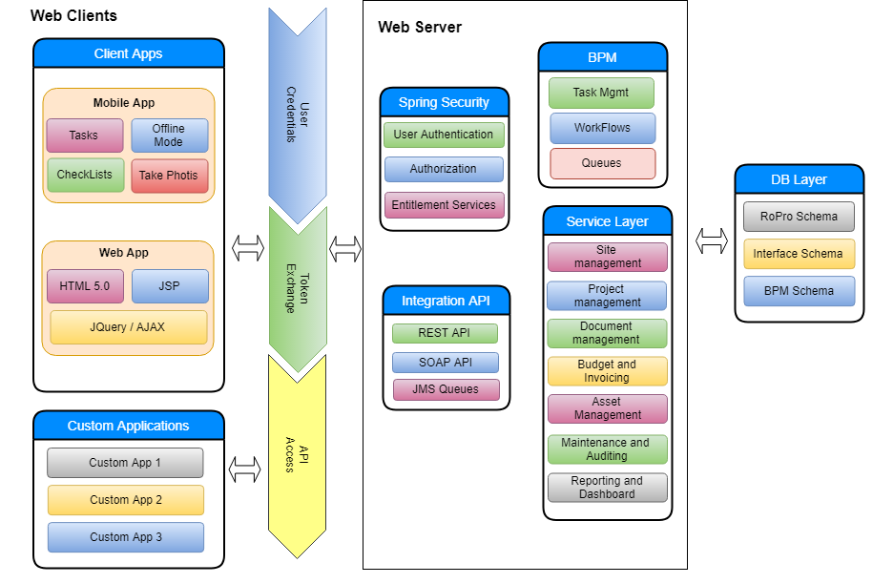

Project Title: MobiTrak:
Duration : 1 month
Technology Stack : iOS (Swift) Android with Kotlin, SprintBoot (Java Server side)
Team Size : 4
Name of the client : OJAS Innovative technologies
Architecture : MVC

Description:
MobiTrak solves this problem and help the users, who lost their valuable mobiles. Users can register their Mobile Phones with IMEI Number and the basic information and can mark as Lost Phone. In the Second Hand Mobile Market, when a Customer is buying a Mobile, they need to send SMS or Whatsapp with the IMEI Number of the Mobile they’re buying, and MobiTrak will respond by checking the database, whether it’s a Lost Phone or not, respond immediately. If it is a Lost Phone, Customer will not buy, and MobiTrak also notifies the user who lost the phone about this enquiry.
.

Project Title: Book My Purohit
Duration: 1 month
Technology Stack: iOS (Swift) Android with Kotlin, NodeJS with MongoDB (Server side)
Team Size: 12
Name of the client: OJAS Innovative technologies
Architecture: MVVM

Description:
Through this app, you can find the nearest Brahmins, Bhokta, Kanya, Suhasini to complete the Ceremonies at your place. You can find various details like the experience, Cost, Reviews etc of the Purohit and you can choose the one that best suits your needs. Once booking request is raised and confirmed by the Brahmin, you can just relax and assured that your Ceremony is confirmed. This app also brings other information about Puja Samagri and will list out the Vendors who can arrange those material to perform the Puja/Rituals.

.

Project Title : Traffic Sudharo:
Duration: 4 months
Technology Stack iOS (Swift) Android with Java , NodeJS with MongoDB(Server side)
Team Size: 5
Name of the client: OJAS Innovative technologies
Architecture: MVVM

Description:

Traffic Sudharo is a great initiative enabling the Citizens to report Traffic Violations to the appropriate authority this application. This enables the user to Post Issue (Traffic Violation) by capturing the Photos from the Mobile Camera and it will automatically read the Geo Location, Date and Time Etc. It will also allow the users to report the images which they’ve captured out of the application.

The Issues reported will be verified by Traffic Sudharo Back end team for obnoxious or obscure images and approves or rejects the issue. All the approved Issues will help the Users get Reward Points as per the Policy of Traffic Sudharo, which the Users can check in their Rewards Module in the app.

Project Title : Keap
Duration: Maintenance Project
Technology Stack: JSP,JQuery,Java Script,CSS,HTML,Ajax,Docker,MySQL,Java and it will give support for Windows,Linux,MAC Operating Systems.
Team Size: 11
Name of the client: OJAS Innovative technologies
Architecture: MVC

Description:

Keap is all-in-one CRM, sales and marketing automation software to help consistently win more business.It helps to grow small and medium business. It houses client activity and communication in one place. promptly responds to incoming leads and existing contacts by sending highly personalized communications that drive action or sales. Keap sends reminders, online appointments, quotes, and invoices.

Project Title: SEPA Pavoo
Duration: 8 months
Technology Stack: NodeJS, Maria DB, HTML, CCS3, Angular, APIs, Micro Services
Name of the client: Sepa
Architecture:

The single euro payments area (SEPA) harmonizes the way cashless euro payments are made across Europe. It allows European consumers, businesses and public administrations to make and receive the following types of transactions under the same basic conditions
- credit transfers
- direct debit payments
- card payments
This makes all cross-border electronic payments in euro as easy as domestic payments.

Project Title: SEPA Muse
Duration: 8 months
Technology Stack: NodeJS, Maria DB, HTML, CCS3, Angular, APIs, Micro Services
Name of the client: Sepa
Architecture:

Sepa MuSe – is Single European Payment Area multi Services. This is a platform, which is integrated with multiple service providers like KYC, Merchant, SMS providers, EWallet card issuing providers, SEPA, SWIFT etc.
Sepa Muse is multi-tenant platform, which can be accessed by multiple banks for various services like e-wallet, transfers within Europe region and international transfers.

